THE HORMONAL MAIL

THE OFFICIAL QUARTERLY NEWSLETTER FOR CLASSIC LIVESTOCK MANAGEMENT SERVICES

VOLUME 1. NO. 1.

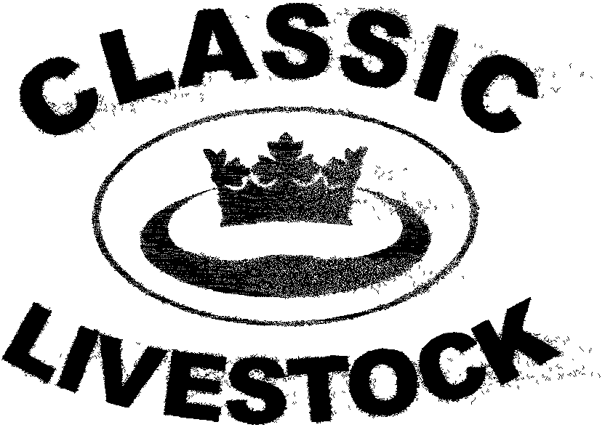

ACN 092435571
P.O. BOX 1181, PHONE : 0741297029.
MARYBOROUGH, 0411201879.
QLD. 4650. FAX. : 0741297029.
Email:- classic@classiclivestock.com
www.classiclivestock.com

EDITORIAL
Welcome to the first edition of the Classic Livestock Management Services newsletter. It is our hope that we can produce this newsletter at least on a quarterly basis. No doubt the content and direction it takes will change over time, or at least, we hope it will. The content will also depend to a large extent what you, the readers, would like to see in it. So please feel free to give us feedback and to ask for the type of information you would like to read.
In this edition, we will have some thoughts on our basic philosophy, an excerpt from the CLMS manual and what our plans are for the next few months. I will also add a copy of a letter that was published in the Queensland Country Life, the largest rural paper in the state of Queensland that is published weekly. It is in response to a letter in an earlier edition from a reader who felt that there is not enough practical information provided to the buyers of stud bulls. The reader felt that the emphasis in providing data is only focusing on the EBV system and doesn’t address some of the more practical aspects of breeding such as age at first calf, ease of calving and inter-calving interval.
It is our aim to make this newsletter interesting and informative as well as a way we can record our views and your’s as well, on the direction of the livestock industry today.
To this end we will certainly be focusing on some of the core issues of our business such as balance and consistency being the pathway to quality. Key issues such as hormonal activity will be discussed regularly.
***************************************************

THE FUTURE.
CLASSIC LIVESTOCK MANAGEMENT SERVICES is a company whose ultimate aim is to be a company for all livestock producers. The company is asking for an opportunity from producers and in return will provide an integrated management system that will take the industry onto a higher level of achievement. The aim is to work with existing organisations to achieve this. We believe we have the means if you have the faith.
***************************************************
COMING EVENTS

SEPTEMBER 8 – 17 – Visit by Gearld Fry and associates from the USA. (Approx. dates only – To be confirmed)
SEPTEMBER 20 – 30 – Re-evaluating grading system
OCTOBER – Visit North America – evaluator training school and seminars as demand dictates.

***************************************************
SUCCESS:
At age 4 success is . . . not piddling in your pants.
At age 12 success is . . . having friends.
At age 18 success is . . . having a drivers licence.
At age 35 success is . . . having money.
At age 50 success is . . . having money.
At age 70 success is . . . having a drivers licence.
At age 75 success is . . . having friends.
At age 80 success is . . . not piddling in your pants
***************************************************
THE CLMS SYSTEM.

As we have become more focused on developing this business, it has become even more obvious that there are many more aspects to consider in developing a system or program that can deliver extra benefits to our clients than we initially planned to use. To this end, we are continually working on adding important measurement options to the system to ensure that we cover a wide range of animal requirements.

To this end, much of our time to date has been used to research and study nature’s phenomena, the cloven hoofed animal. This means that by the end of this year we will be able to offer producers up to five evaluation options. Three of these will be visual and kinaesthetic assessments and two will be objective measurements.

At this stage we still have some work to do to refine this fuller system, but at present we can still offer a very comprehensive grading system. What we belief is that if an animal scores well in one method, they will also score well in another. In a sense, each method will be a confirmation of the others. Having said that, it will still be possible to get a reasonable idea of an animal’s potential product quality whether it be meat or milk through just one or two of the methods. However, a full evaluation will be more comprehensive and provide much more data and, of course, we will probably have to charge a little more!

***************************************************

OUR SERVICES

- Livestock Evaluation.
The company will provide an evaluation service and grading system based on the production of tender, palatable meat products.
- Carcass Evaluation.
The company will evaluate all carcasses prior to consumption to guarantee the grading system.
- Pasture Management.
Support will be available for clients who are dedicated to increasing the productivity of their pastures and the efficiency of their grazing system.
- Fodder Conservation
The company will work with clients to develop fodder conservation programs that will ensure a continuous supply of good quality feed can be provided on farm at all times.
- Marketing.
The company will co-ordinate, but not necessarily be directly involved in local, national and international marketing of meat products including value added products.
***************************************************

ASTROLOGY
Two blondes living in Oklahoma were sitting on a bench talking.......and one blonde says to the other: "Which do you think is farther away..........Florida or the moon?" The other blonde turns and says "Helloooooooooo, can you see Florida.......?????
***************************************************
HORMONAL ACTIVITY.
The importance we have placed on this trait is highlighted by the fact that we include it in both our meat and breeding evaluation systems. It is so critical because it is the best mirror we have on what is happening inside the animal and is integrated into most of the animal’s functions. It affects things from their appetites to their reproductive potential and on to product quality and in the case of meat in its taste.
It is so important that the latest evaluation grading method we are working on is based on an animal’s hormonal activity and its related glandular function. This method will be based on the external signs that the animal provides for us on the functioning of these internal activities.
The industry is being misled in selecting for high and fast weight gain, low fat cover, double muscling and butt shapes that are perceived to be visually correct. Breeding for these traits is hampering the activity of important glands such as the pancreas and the thyroid glands and thereby reducing the hormonal activity in animals.
***************************************************
BLONDE ON THE SUN
A Russian, an American, and a Blonde were talking one day. The Russian said, "We were the first in space!" The American said, "We were the first on the moon!" The Blonde said, "So what? We're going to be the first on the sun!" The Russian and the American looked at each other and shook their heads. "You can't land on the sun, you idiot! You'll burn up!" said the Russian. To which the Blonde replied, "We're not stupid, you know. We're going at night!"
***************************************************
LETTER TO THE EDITOR – QUEENSLAND COUNTRY LIFE – 22 JUNE 2006
In his letter to the editor in the QCL – May 25th. edition, Laurie Pampling raised some interesting points about the type of information that is available to bull buyers. He suggests that there is not enough objective, relevant, practical information available for buyers. Our company, Classic Livestock Management Services has just developed a much wider and balanced assessment system that will provide breeders with pertinent information about their animals that addresses many of the practical issues that Mr. Pampling raises.
Our focus is on producing balance and consistency within our beef herds. We address the actual selection of individual breeding stock, as well as other significant factors that directly affect the animal’s life long performance such as manager efficiencies, feeding, grazing and animal health management. There is only one real measurement of a successful breeding and commercial production enterprise and that is in returns per hectare. Maximum returns will only be achieved by breeding animals that are environmentally suited to local conditions and reproduce consistently and efficiently.
Breeders are being dictated to and controlled by influences outside the breeding industry who are only interested in their own bottom line profit (and understandably so) and by scientists paid by these company’s to research what they want researched or by governments who know even less about the industry, but demand results at all costs. Selection of breeding stock has become focused only on traits such as weight gain that will benefit these external influences. Scientists would be supporting the industry much more positively by finding ways to objectively measure the practical aspects of breeding mentioned by Mr. Pampling and those that many of our true breeders have had passed down to them subjectively through generations.
The quest to breed the “perfect” animal through cross breeding is, in reality, taking us further away from perfection. Each breed has, somewhere in its history, the genetics to produce a balanced, efficient and consistent outcome for the true breeder who knows what traits will provide that balance and consistency to produce a good return per hectare. Too much time and money is being spent in the industry chasing a magic solution to breeding when a simple, practical answer is staring us in the face.
***************************************************

BALANCE AND CONSISTENCY.

We believe that the most important consideration within the livestock industry, as in most enterprises, is to have balance and consistency which will then lead to sustainability. In fact, without the association between these components of the industry, then even consistency is not possible and especially not in the long term. There is a huge amount of information from many sources available to us today, even to the extent that it can become overwhelming and confusing.

To that end, we have tried to present some of the simplest, yet most important ingredients from the foundation needs of the industry in a way that will be supportive, non-intrusive and informative, yet effective and satisfying.
In our manual, we have spoken consistently of the importance of balance and it needs to be added that we see inter-relationship as an important ingredient of balance. It is the catalyst for success in any enterprise that has any reliance on nature.

Despite all that we have learned of our world, nature still holds secrets that we need to respect and work with that will ultimately determine how successful we are at what we do.

Balance is also the key to our whole evaluation system. The closer to the ultimate that breeders can get to for each of the traits that we have identified, the closer they will get to having an animal that is balanced in terms of maternal and paternal traits, breeding potential, meat and milk quality and growth conformity. The more traits that score highly in each animal, the more likely that the remainder of the traits will score highly. There is, in a sense, a flow on effect and a definite relationship between traits. Further mention is made of this relationship in later comments and, in particular, how internal biological activity in an animal is translated into external visual signs. As more traits improve, given that similar types of animals are used in the breeding program, then the more likely that the offspring will develop an inter trait balance. In most cases, when one trait is good, it will mean that some or all of the related traits are also good.

Looking at it from a genetic perspective, the traits that we discuss are influenced by a number of genes. Some are more influential than others. If we take the trait of tenderness, for example, then the current general consensus is that there are probably about five to seven main genes for this trait and possibly another thirty that have some influence. When breeding, this fact is important in that it is all very well to select for those five to seven main genes, but what effect does that have on the strength of other genes?

If this effects some of the other genes that are possibly important for other traits in the animal, then there could be a negative outcome in terms of producing a very tender offspring in that its production capacity may be limited because of the effect on genes that, for example, increase the rib spring of the animal and therefore its capacity to take in adequate feed to produce a profitable conversion of grass to meat.

This has been highlighted by the fact that in our experience we have found that some of the finest boned animals that will produce very tender meat just don’t have the body capacity and size to produce enough meat quickly enough to be a profitable option in a beef herd. They may well have other strengths that will mean that they can be a useful part of an enterprise. One such breed that portrays this is the Jersey. In our experience, this breed has generally graded consistently highly for bone structure, yet just doesn’t produce a large quantity of meat quickly enough to be an economic proposition unless crossed with a beef breed. However, they consistently produce very high quality milk, even if they are not the highest yield producers of the dairy breeds. Many of you will have eaten meat from the Jersey house cow’s calf that was crossed with a beef bull and found it to be very edible, if not better than any meat you have ever eaten.
From the Classic Livestock Manual - 2006
***************************************************
CURRENT EVENTS.
- Six of our shareholders recently spent a day evaluating the possible options available in regard to using electronic probes to identify some of the internal features of cattle that may lead to this providing an alternative and objective method of identifying meat quality. The probe was used to look at such things as eye muscle characteristics and the intra-muscular fat layers on the animals.
Whilst we are currently evaluating the results of this work, there are some indications that there could be some correlations that can be identified that will assist in identifying meat quality. There is still quite a lot of work needed before we could present anything for public scrutiny or use if, indeed, the path we are following does prove to be useful.
In the meantime, we will continue to investigate more objective ways that might lead to better identification of meat quality in live animals in a simple and on the spot way that requires minimum handling of the stock. It is our aim to be able to provide all the evaluation data that producers require in just one yarding of the animals.
- We have just taken delivery of a Nadana bull called Hugo. He is currently situated at Maryborough, but the plan is to take some straws of semen in the next couple of months that will be available for public use and also possibly lease him to interested Nadana breeders. This bull was the first bull of his breed to be brought to Australia and is currently 12 years old. The Nadana breed is the original miniature Bos Indicus breed originating in Sri Lanka and has a small but enthusiastic Australian Breed Society. We have evaluated a number of these cattle including some offspring of this bulls’ and they have scored very highly for meat quality against our evaluation system. In fact, they would have the highest percentage of high grading animals of any herd or breed on the initial evaluation that we have evaluated.
3. We are now getting serious about planning for a visit to North America in October to hold some seminars to publicise the system and, if public interest is forthcoming, to hold a 5 day evaluator training program. We are at the stage now of asking any people who would be interested in the above to contact us as soon as possible so that we can finalise our plans. Please contact me for further information and/or to book for one of the events. We are still finalising locations, but the evaluator training program is likely to be held in Sasketchewan in Canada.
4. We are also looking forward to the visit in September of Gearld Fry and his Associates. Unfortunately, they will probably only be in Australia for about 7 – 10 days, but if you would like to meet them, please let me know and we will do our best to arrange a meeting or maybe a field day or seminar.

PLEASE FEEL FREE TO CONTACT US ABOUT ANY ITEMS IN THIS NEWSLETTER, ON OUR WEBSITE OR IN OUR NEW MANUAL. WE WELCOME PRODUCER INPUT AND INTEREST AND WANT TO INVOLVE YOU IN WHAT WE ARE DOING.
Disclaimer: - Information contained in this newsletter is believed to be true and accurate at the time of publication. Classic Livestock Management Services is not liable to any person or organisation, whether in negligence or other wise for anything published or omitted from this publication.

