THE HORMONAL
MAIL

THE OFFICIAL QUARTERLY
NEWSLETTER FOR
CLASSIC LIVESTOCK
MANAGEMENT SERVICES

VOLUME 1. NO.12.
APRIL 2009

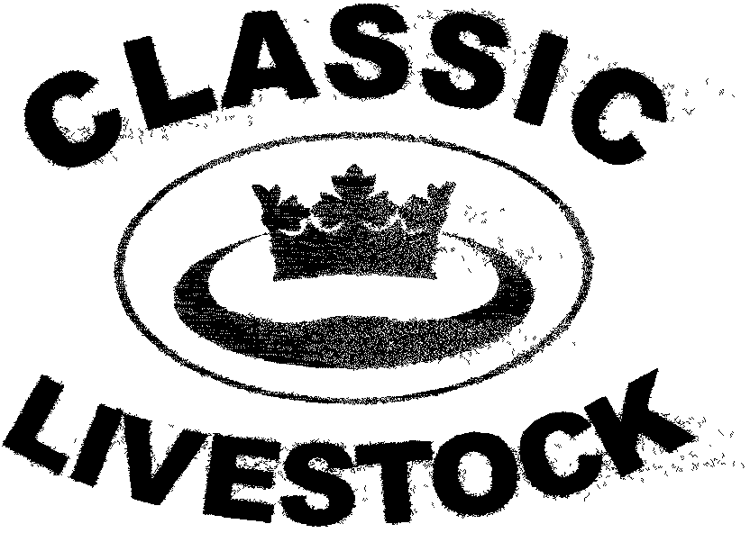

ACN 092435571

P.O. BOX 1181,
MARYBOROUGH,
QLD. 4650.
PHONE: 0741297029
0411201879 FAX. :0741297029.

Email:classic@classiclivestock.comWebsite:www.classiclivestock.com

EDITORIAL.
Welcome to this quarterly newsletter. Firstly, I must apologise for this newsletter being a little later in the month than I would usually like to get it out by. I know that it is a well used excuse these days for delays, but we really have had some problems with our computer which has taken a couple of weeks to rectify. Fortunately, it ended up being something not too serious, or at least, not too expensive.
I realise that the topic of balance and a holistic approach is one that we have discussed several times in previous newsletters. However, it is the key platform on which our business is based so I don’t make any excuses to continue to publicise that aspect of our business. In this newsletter, we hope to further explore this issue both from a personal farm owner/manager perspective as well as the practical management perspective of maintaining our natural resources in a sustainable way.
I had the pleasure of attending two field days recently that highlighted the interest that is continuing to develop now in taking these more sustainable approaches and how the benefits of producing food in a sustainable way can be demonstrated to the consumer so that they will support this direction. We have raised questions previously about the way the agricultural industry and particularly the corporate input is more interested in quantity than people’s health. Sure, they keep on espousing how the food we eat is of the highest quality, but we must be aware that quality is more than skin deep and just because it looks fresh and bright does not necessarily mean that our digestive system will look the same way after it has passed through it.

FIELD DAYS – DISCUSSION GROUPS
As I mentioned in the editorial, I have recently had the pleasure of attending two field days in Northern New South Wales that were focused on producing cattle in a sustainable way using organic farming practices.
One of the days, held near Armidale, was sponsored by the local Land Care group. It was attended by about 70 people who heard from speakers on pasture and grazing management, focusing on native grass species, as well as about the most topical subject of the moment, carbon storage and emissions. There were a number of interesting points raised during the day. Probably the key point that again highlights our balance arguments was the importance of good ground coverage to reduce carbon emissions and to obtain that there is well documented data that supports sound planning for grazing practices that will encourage grass plants to grow in a healthy and sustainable way. As the speakers at the field day pointed out, maintaining a healthy soil with plenty of biological activity is dependent on sound pasture and grazing management and vice versa. Including a balance of native species along with improved pasture species and legumes in a pasture is important for both soil conditioning and animal health. Much of the discussion on pasture management and grazing practices that was held covered the main points that are raised in our company’s book, A Vision Tender.
The need to plan pasture management strategies and grazing rotations was highlighted. In particular, the need to only graze pastures for a short period of time i.e. 3 days as a maximum in most situation’s, was discussed. With most species in average growing conditions, the leaf regrowth will be long enough to be grazed again by cattle after those 3 days. If this happens regularly, as when cattle have a large area with ongoing access to the plants, they will tend to just select the sweetest species and continually graze these, leaving other plants to grow out and become “clumpy”. This continual grazing of the shorter, sweeter leaves means that those particular plants don’t have a chance to grow enough leaf area to go through the photosynthesis process which is critical for ensuring root growth. Consequently when this happens the plants root system becomes weaker, it becomes smaller and stunted and therefore can’t cover as much ground space thus allowing more of the less desirable species to grow and at the same time also leaving more bare earth space where carbon is emitted from.
Remember also that with the vast majority of grass species, when the fourth leave starts to grow the bottom leaf starts to die. This happens regardless of the time of year. It is just that at the peak of the growing season the leaves are much larger and further apart than in the slower growing seasons. Therefore, nothing is gained by leaving pastures when they reach that 4 leaf stage before grazing. This means that the grazing plan needs to vary with the seasons, but always with the knowledge in mind that to optimise plant production, a short grazing time on a smaller area to ensure an even sward is left is important. When growth exceeds a property’s grazing capacity, usually in the peak growing season, the excessive growth can be conserved as fodder, hay or silage, or mulched back into the soil.
Some discussion was also held on measuring the amount of dry matter available both before and after the stock grazed each pasture. There are tools available to assist in accurately measuring the feed available and those present who had used these tools agreed that after initially using them they were able to judge fairly accurately by eye how much pasture was available prior to grazing and what was left after a 1 – 3 day grazing period by stock.
At the end of this day, over 20 people remained for nearly 2 hours to discuss our livestock grading system and to see a demonstration of some of the key traits to look for when grading for meat quality.
The second field day at Grafton was sponsored by a local organic farmer and suppliers of organic soil fertilisers and conditioners. This day had a greater emphasis on soil nutrients and conditioning with some good samples of local soil before and after using some of the organic fertilisers. It showed a considerable increase in worm activity and root development in the treated soils.
We also had a good opportunity to discuss the key traits for meat and milk quality on a range of cattle bred on the property where the field day was held with the crowd of over 50 people who attended. There was considerable interest in learning more about the identification of the escutcheon and how it relates to the quantity and quality of milk produced and that it is not just restricted to dairy cows.
It was gratifying to see the number of people in attendance at both days who were relatively new to primary production. There were probably more people who fitted into this category than those that could be termed as traditional 2-3 generation and older producers. On both days, there was a lot of energy and enthusiasm generated about the future of agriculture if the organic methods discussed are put into practice. In many ways there was a sense among those present at both days that what are now recognised as the traditional methods of farming, such as the use of chemicals as the corner stone of production, are starting to run out of steam. Even though science in coming up with new methods to increase production and especially quantity, they are all very much coming from an inorganic and synthetic base. The feeling was that this is just sucking those using these methods further into a bottomless pit that will eventually have no way out or end up in a dead end.
That is, literally, dead from poisoning!

CLMS HAS A ROLE.

One of the reasons that we, as a company, are keen to be involved with the type of field days mentioned above is so that we can ensure that the meat and milk produced by organic farmers is of the highest quality. Just because animals eat organically produced grass in an organically sustained environment doesn’t necessarily mean that the end product will be high quality. Certainly, it will positively influence the taste of both meat and milk, but it will not necessarily ensure other factors and particularly tenderness in meat and quality in milk. These are more genetically influenced factors and so there is still a very important need to select for these traits in any breeding program. This is where we know that our system can play a pivotal role in the organic industry. We have the system that will identify these traits and support producers in being able to put together a breeding program that is going to fully support the rest of their organic operation.
As a company, we are keen to work with producers growing organic meat and milk to provide an evaluation system that will take their products to the top of the mountain in terms of marketability and consumer demand.
We are able to provide the evaluation system that will do this and are also very keen to work with producers, particularly at this early stage in the development of the organic industry, to develop a consistent supply of product on a regular basis into selected, receptive markets.
We have already had initial discussions with some organic producers about forming market groups to sell their products to consumers. It may mean that we need to explore other marketing methods to the traditional ones to generate a viable through put, but if that is the case then we are prepared to do it. Certainly, there are a number of innovative organic growers who are successfully marketing there products. However, most will admit that it has been a long and time consuming challenge for them to get to where they are now. That is why we see a role, albeit a very non intrusive one, to assist with coordinating groups of producers to market their products.
Because the current production levels are very low, it is difficult for any one producer to be able to sustain a regular market for 12 months of the year with any quantity of meat, so it is with that in mind that we are prepared to coordinate a more consistent approach, bringing together a larger and more attractive quantity for most marketers.
We also see this as being an opportune time to really get behind the people involved in the organic industry. As I mentioned in the previous article, quiet a large percentage of those attending the organic field days are relatively new to primary production. Whilst they will be the first to admit that they have a lot to learn about agriculture in general, they are though not as blinkered in their approach to different ways of producing food as some of our traditional producers are.
In many cases these people have been very successful in other businesses and so bring a very professional business approach to their new enterprises. They also bring a different approach to planning and problem solving. In many cases they bring a new creativity to agriculture and challenge the way things have been traditionally done. It is no longer appropriate to call these people just “Pitt Street or Collins Street” farmers who have no idea what they are doing. Our experience is that they have an insatiable appetite for knowledge about their new enterprises and are not prepared to accept the status quo. Very often, because as outsiders coming into an industry and with experience from other businesses, they can see the things that aren’t working in agriculture much more clearly than those of us who have been involved in it all our lives.
From our company perspective, we are motivated to support these people because we are learning much more about what is out there in the business world for all of us if we are prepared to be open and consider different approaches. It is certainly taking us out of our traditional farming “comfort zones”, but there is definitely plenty of room for other methods of production that we, as traditional producers, have been blind to for too long. Even if that direction means going back in time and learning more about the natural ways of production then we need to accept that may be what we need to do. Today, we have the approach/attitude that if it is not new, never been used before and can’t be scientifically proven, then it should not be considered. Maybe there other ways and some of them may well be rooted in the past.

WHAT’S PLANNED

We are gratified by the growing interest in our business and the number of people who are taking a more holistic and balanced approach toward their livestock businesses. We are finding more and more people with similar philosophies to those of our own.
Over the next few months, we are planning to be involved in more field days. The next big beef cattle event in Queensland is the tri-annual Rockhampton Beef Week on in the first week in May. We will be there for a couple of the days at least and will be spending some of that time on Eddie Streeter’s “Fairy Springs” Brahman stud stand and we are most grateful to Eddie and his family for this opportunity.
We also have a field day planned for the 18th. of May at Ray Hull’s property south east of Millmerran which is being held in conjunction with McLeod’s Organic Fertilisers and the local Land Care group. We would like to thank these organisations and Ray for arranging this event. It is open to any interested parties and we will have a number of Ray’s cattle available to evaluate and discuss in reference to our system.
The planned trip to Nth. Queensland to conduct 2 field days is still planned for mid July and we just need to confirm dates and venues for these events. Please contact us if you are interested in more information.

Chinese Proverb – Man who eats many prunes gets good run for his money!!!! OR – Women who puts husband in doghouse soon find him in cathouse!!!!!!!!!!!!

**********************************
SOLITARY
REFINEMENT
This is a small section on some thoughts about the loneliness or aloneness that many primary producers so often experience on a daily basis. It often just the nature of the business that we find ourselves alone whether it be sitting in a tractor, on a horse or doing any of the multitude of roles that are part of a farming enterprise that are one man or woman jobs.
Let’s explore some of the ways that we can approach this fairly common aspect of farming. It is about exploring ourselves, because many of us don’t give this topic much, if any, conscious thought. We either fear what we might find in the inner depths of our minds or make excuses for not going there. It can end up becoming a dis-ease within us if we don’t acknowledge it, sometimes accept it or at least be consciously aware of it. As such, that is, a dis-ease within us, it can manifest itself in many ways including as a physical ailment, tiredness, stress, confusion, frustration and so on.
We don’t necessarily have to do anything about it if it is not something that causes us any concern and is not affecting our daily life or performance as a manager or business owner. In fact, the solitude we experience at these times can provide us with just the time we need to plan future business developments or give thought to personal and family issues.
It is when this loneliness becomes something that we don’t believe anyone else understands, when we find excuses that don’t exist for any little incident and when blame takes very ounce of energy from within us. Energy that we can’t afford to lose and don’t know how to keep and use as the foundation to use to change the way we perceive our world.
UNDERGROUND
ANGELS
Just to finish off the earlier mentions of soil conditioning, I wanted to emphasise the importance that I think we all generally acknowledge that worms play in maintaining a high level of fertility and health in our soils. Unfortunately, this acknowledgement is so often just in the way of lip service. What are we actually doing to not just protect the worm populations in our soil, but to encourage them. I remember being told by my grandfather many years ago that if there were no worms in the soil then it was dead.
The observation that I wanted to make that I think highlights the fact that we are not supporting our worms the way we might, and I think some of you may have similar experiences when you think about it, is that when we were children (in the 1950’s) and our father was ploughing a paddock, we would be amazed by the numbers of seagulls that would follow the plough up and down the paddock eating the worms as they were ploughed out.
By the 1970’s we rarely if ever saw one or two, let alone flocks of seagulls following the plough. Now there may have been a number of good reasons for this. It could be that there were a lot more fish and other food on the coast then for the seagulls, there may have been a big reduction in their numbers, (though this was not evident when we visited the beach) or there may just not have been the worms in the soil for them. This could have been because they had reduced the worm population by so many during the 1950’s and early 60’s that it just wasn’t worth while them travelling the distance for the meagre reward that awaited them or it could have been something to do with the way that as farmers, we had changed about the way we treated the soil.
After the second world war, farming became much more mechanised and therefore larger areas were able to be cultivated in a shorter time and weeds and pests were now lesser of a problem because of the development of chemical herbicides and insecticides. We were also able to test soil for its nutrient content and add artificial and chemical fertilisers containing more of the desired or missing nutrients. This certainly enabled more production of food items and therefore theoretically les people would starve. This was the main motivator for this need to produce more food.
The seagull message didn’t hit home for me until we started using biodynamic farming practices in the mid 1980’s. The amazing thing was that after a couple of years we started to notice that gradually a few seagulls were starting to return and follow the plough again.
Of course, what had happened was that the applications of BD 500 that we had been applying were redeveloping the conditions for the return of the worms into the soil.
*****************************************
Thank you for your continued interest in our newsletters, our website and our book. Please feel free to order one of our books and become familiar with the CLMS system and the directions we are taking in the overall scheme of animal and food production for human consumption
PLEASE FEEL FREE TO CONTACT US ABOUT ANY ITEMS IN THIS NEWSLETTER, ON OUR WEBSITE OR IN OUR NEW MANUAL. WE WELCOME PRODUCER INPUT AND INTEREST AND WANT TO INVOLVE YOU IN WHAT WE ARE DOING.
Disclaimer: - Information contained in this newsletter is believed to be true and accurate at the time of publication. Classic Livestock Management Services is not liable to any person or organisation, whether in negligence or other wise for anything published or omitted from this publication

