THE HORMONAL
MAIL

THE OFFICIAL QUARTERLY
NEWSLETTER FOR CLASSIC
LIVESTOCK MANAGEMENT SERVICES
VOLUME 1. NO.13.
July 2009

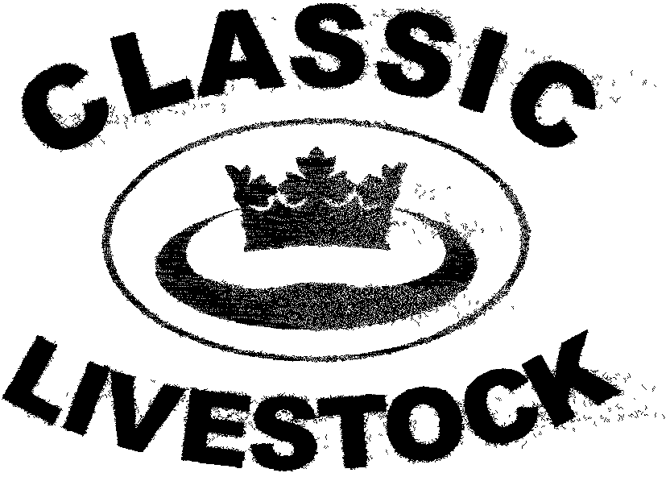

ACN 092435571

P.O. BOX 1181, PHONE: 0741297029.
MARYBOROUGH, 0411201879.
QLD. 4650. FAX. :0741297029.
Email:classic@classiclivestock.com
Website:www.classiclivestock.com
EDITORIAL.
Welcome to our quarterly newsletter for the July quarter of this year.
In this edition, I just wanted to recap a couple of recent events, in particular, the field day that was held at Ray Hull’s property at Millmerran in May. There are also details of the days I will be in North Queensland in July.
I also wanted to again add some material for discussion, argument, reflection, dismissal etc. about the human element of primary production. There is so much about all the developments that are happening and all the new discoveries that are occurring in the industry that I wonder that at least some of you don’t feel a little overwhelmed at times. Much of this development and discovery is good and is designed to make our enterprises more efficient and economic.
I know that some of you might argue that I am getting too far away from the basic evaluation of animals that is our core business in many of our newsletters and in some respects you would be correct. Whilst we haven’t, and I hope, never will, lose sight of evaluation being what we do primarily, we also know that there are many other complimentary factors that cannot be ignored if we are going to produce high quality products.
Bear in mind that we have also produced a book that outlines our evaluation system in detail and don’t want to just keep re-hashing that information in the newsletters. That is not to say that we won’t be adding bits and pieces from the book to the newsletter occasionally, but doing that doesn’t give the big picture of the system that will allow you to see and use it on an ongoing basis.
THE MILLMERRAN FIELD DAY
Around 60 producers attended this day held at Ray Hull’s property “Raydell”, Millmerran. The day was sponsored and organised by the local Landcare group and our thanks go to them for putting on a very well organised day. The work that Landcare do in supporting sustainable agricultural practices cannot be underestimated and particularly now with the emphasis being placed on climate change and water conservation. We have now been involved in 3 field days this year with Landcare and have found their commitment to the future of agriculture is of the highest order.
Our most sincere thanks go to Ray and Dell Hull for so graciously allowing their property and stock to be used for the day. Their hospitality could not be faltered and the way that they presented their property and stock was a great credit to them. It’s always at least a little daunting when you have a group of people, many who you don’t know, descending onto your property.
Thanks also to Bevan McLeod, of McLeod’s Agricultural and Organic Fertiliser for his role in setting up and promoting the day.
THE KEY SPEAKER.
The key speaker was Carolyn Ditchfield, an Entomologist and Biological consultant from Inverell in New South Wales, who is committed to learning all she can about the link between the soil and the health of plants, animals and humans and the biological agricultural environment as a whole.
Carolyn’s topic for the day was “Rehydrating Landscapes”. Her presentation was full of the passion that she so obviously has about this subject. She provided some history to the group about the directions we have taken in regard to water conservation in this country including work done by people like Glen Morris, whose research found that the water to humus ratio is 4 parts water to 1 of humus, Peter Andrews and Colin Seis and Darryl Cluff, who discovered that Australia’s flood plains were originally covered in grasses and not trees as was the general perception.
Carolyn spoke about the growing problem of dryland salinity and how this has occurred with the reduction of native perennial grasses and their replacement with annual crops and improved grasses. The native grasses acted as massive sponges and held water in their relatively dense root systems which also acted as large pumps and pumped the water up or down through the soil as determined by climatic conditions. They encouraged the storage of water in what Carolyn termed the “hyporheic zone”. This refers to the subsurface flow of water between the water table and the surface water flows. It is not water table. It is this sponge carbon zone created by the plants roots where water flows across the landscape by gravity.
The modern approach to prevent salinity has been to create large drains to remove water from the landscape as quickly as possible. This use of drains, contour banks and deep rooted plants is, in fact, dehydrating rather than rehydrating the soil. What is happening is that with the removal of the thick rooted vegetation, the salt content of the soil rises and valuable water is leached out of the soil because there is nothing in the hyporheic zone to hold the water.
Carolyn also touched on the importance of a good even sward of grass as a very effective and efficient way of retaining carbon in the soil. Bare earth, including fallows, is a good way of speeding up carbon emission.
Pasture management practices that encourage plants to cover all the surface area of the ground assist with the retention of carbon. Fortunately, these types of planned grazing practices are now becoming more common amongst our producers. In our book “The Vision Tender” we explain a very adaptable planned grazing method that encourages the grazing of plants at their optimum growth level on a regular basis. This prevents the pastures from becoming long and rank and dominated by a few large plants with bare areas around them as is often the case when animals are allowed to graze the one large area for a long period of time. They select the sweetest plants and continually graze them with the result that their root system diminishes and they become weaker and eventually die out leaving a few large, rank and much less palatable species.
In light of Carolyn’s comments, this has the two fold affect of reducing that thick mass of subsurface roots to retain soil water and increases the area of bare soil where carbon will be emitted.
PRACTICAL SESSIONS.
Soil conditioner.
During the afternoon session, Bevan took those present out to one of Ray’s paddocks where Ray had applied some of his soil conditioner. The group were able to see the difference in colour and growth of the plants on the areas where the soil conditioner had been applied. The conditioner is a mix that Bevan makes up that is designed to stimulate the micro biological activity in the soil so that there is a greater availability of nutrients for the plant. It also works on re-invigorating the soil within its own biological system so that it is not reliant on the introduction of large quantities of external fertilisers and particularly acid based fertilisers. Bevan’s conditioner is ideal for application on properties that are either organically certified now or are aiming to become so. This is one of the areas of production that we are finding is really growing in interest now and especially with beef producers. Bevan also showed the group a soil profile that he had poured coloured water through earlier in the day so that they could see the movement of the water through the soil and how it moved laterally as well as straight down.
Cattle evaluation.
Ray has a very good quality Red Poll herd and he sells 4 – 6 yearlings every 1 – 2 months to a set group of private clients, mainly in Brisbane, after having them processed at the local Millmerran abattoir. Just prior to the last lot being processed, I went out to Ray’s property and graded them for tenderness. The four yearlings that Ray had selected were all good young cattle and there wasn’t a lot of difference between them in regard to tenderness. They would have all been quite acceptable to sell within the CLMS grading system. However, we selected the toughest and tenderest under the system and Ray kept some of the rump out of each which we grilled and gave to the participants at the field day during the lunch break for them to do a taste test on as part of my presentation. As I said, there wasn’t a lot of difference, probably about 1 grade in our grading system between the two samples, but those present had little trouble selecting the more tender sample on the grading system.
During the afternoon, we looked at a number of the cattle that Ray had kindly yarded for us in regard to the main traits that the system use as part of the evaluation process. We were able to put a number of cows and heifers in the crush and look at them closely in regard to meat and milk quality as well as the other key traits. With a large group around one crush it is not possible for everyone to be able to see as much as they would like, but we most of those present were able to participate to their liking. Those who wanted to were able to feel the skin and bones of the cattle and closely observe the various swirls and escutcheon patterns. Few of those present were aware of the escutcheon pattern that provides a strong indicator of milk yield and of the yellowish skin like flakes in the swish that indicate a high protein yield in the cows’ milk. This created a lot of interest although the unfortunate thing from one perspective was that there was not a lot of variation in the patterns on Ray’s cows or heifers. On the other hand, from Ray’s perspective, this was good because his cows and heifers all display a very prominent escutcheon which indicates high milk yield. This is because Ray considers milk yield to be of the utmost importance when selecting his breeding females and his herd certainly vindicates his sound judgement. In fact, his herd is, on average, the best beef herd I have seen in terms of milk production. It was good that those present could see what a good escutcheon looks like and can now compare their own cows with those they saw at Ray’s.
Overall, if the number of questions asked and the slowness of many to leave after the day concluded is any indication then there was a lot of interest from those present which was very gratifying for all involved for the organisation of the day.
We would like to thank all those who attended and hope that the time you spent there was not wasted.
***************************************************
The old ringer was late turning up for work after a hard night and the boss yells, “You should have been here at 8:30”.
The old ringer replies, “Why? What happened at 8:30?”
***************************************************
RESEARCH OPPORTUNITY.
As a company, we have been discussing options in regard to accessing methods of providing more statistical evidence that the evaluation methods we are using are reliable and repeatable. As well, there are several other areas that we believe there are correlations in as far as many of the traits that we have identified practically and we would like to be able to document some strong research basis for these. Areas such as the relationship between feed conversion rates and meat and milk quality, as identified by the CLMS system, are things that there is little hard statistical evidence to support even though our observations would tell us that this is a likely conclusion to draw.
To date, all our own research has been criticised because we have had to do it ourselves and we have been accused of not being impartial in our results. Certainly we have always been aware of this being an obvious criticism, but we did need to start somewhere to provide a basis on which to build our business. The frustrating fact about this is that those who criticise are not prepared to take themselves out of their own comfort zone and agree to do some impartial trials for us. Admittedly, it is about 4 years since we last attempted to do some work in what we thought was an impartial environment and hopefully some of the industry, at least, is starting to understand what is happening, or more precisely, what is not happening to take the industry forward. Certainly, we don’t have all the answers, but we do have some that cannot be ignored and need to be examined more closely and then implemented.
It has become painfully obvious over the years that the industry politicians and scientists are only interested in grand plans that will benefit their own pockets and those who are filling them. The grass roots “cowboy wisdom”, as Gearld Fry calls it, has been forgotten and replaced by dollars and how to get them as quickly and cheaply as possible. The frustration is that people have forgotten that the way our forefathers produced beef of the highest quality was just as, if not more economical, than the consortiums running the business today.
What we are aiming to do is to link the two and to do this we are hoping to find an agricultural scientist who is looking for a subject for post graduate study in this area. We are putting together a set of criteria to follow in regard to the areas that we would like to see some research done in that will be fairly broad and contain enough flexibility to be attractive for post graduate study. We believe that this is an area for some ground breaking scientific research in an industry that has developed a tunnel vision approach to where it is heading and as such has little in the way of new areas to offer for post graduate study that would be of any real benefit to the industry.
We will be putting more information about this topic, including the criteria for research on our upgraded website which we hope will be available in the next couple of months.
If you know of anyone who may be interested, please ask them to contact us.
***************************************************
A sign of Ageing: When you sink you teeth into a piece of steak and they stay there. (doesn’t happen with CLMS graded steak though!!!!)

COMING EVENTS
I have finalised the times when I will be travelling to North Queensland. I will be in Mackay visiting producers on the 18th. of July, then going to Cardwell to see some Nguni cattle on the 19th. On the 20th, we will be having a discussion day at Malanda and going through some of the main traits for evaluating meat and milk quality and then returning to Proserpine on the 22nd for a day to visit producers there.
If you would like to catch up during that time, please let me know in the next few days and I will make the time to meet with you. Call me on my mobile phone on 0411201879 please.
I am also aiming at spending a couple of days in the Rockhampton/Biloela area in August/September.
***************************************************
WHEN TO REASON OR NOT
The following is a bit more of my “stuff” coming from the other side of the fence in a sense and I guess I would just like to share some ideas and thoughts about developing an awareness of how the business we are involved in affects us psychologically as well as in the other ways. I know it won’t interest some of you, but for those of you who it does then I hope you can understand what I am saying. Again, just as we have talked about the importance of balance in our individual stock and then as part of our production business in past newsletters, I wanted to touch on the subject of our own personal balance. Some of this has been motivated by publicity in recent days here in Australia about drought and the impact it has on the mental health of our farmers. Whilst drought was the catalyst for this discussion, we all know that there are a number of other events and situations that can occur that are out of our control as producers and especially those controlled by the weather. I will start sharing some thoughts with you in this newsletter then continue them in future editions.
Today’s lifestyle is ever changing and seemingly getting faster every day. We are surrounded by technology and gadgets that do many of the things that once took us considerable time and often that was time that we also had to think things through and were not pressured to make fast decisions. Today’s world is very much a left brained world where everything has to “add up” and make clear pictures of rationality for us. So much of what we do has to be analytically justified.
We forget about our “other side”. There is little room for emotion in the decision making process and if we can’t actually rationally work out the reasoning behind an outcome or event then we should definitely not be going there.
That is despite also being part of a world of caring and nurturing, even though we would rarely, if ever, admit it. I really don’t believe that anyone who has worked with animals can say that at some stage they have not had a special place in their hearts for one or a number of the animals that they have worked with.
However much we look at farming as a business, it will always have a component that contains some degree of emotion, regardless of what the hard heads tell us.
It is about compassion and commitment. There are inputs into the food that we produce that cannot be measured by figures or numbers. These things do affect the quality of that food – the human element that is irreplaceable – the personal touch that is lost with corporate agriculture and science and cannot be measured. It is the connection that carries the life energy from the producer to the consumer.
Whilst it is not something that most of us have paid much attention to in the bigger picture of the day to day running of our properties, our emotional awareness is very important to us to ensure that we are operating as close to 100% efficiency as possible.
So often when events out of our control like drought occur, we tend to focus on keeping the physical aspects of our business together and ignore things like depression, guilt and fear of failure. Depression is a shocking infliction and destroys personal motivation. However, it usually has other emotions driving it and we can easily fall into the trap of using it as a protective barrier to shut out other negative emotions which are often the root cause of depression. We often don’t realise what is happening when psychological factors start to limit our level of functioning. In the next newsletter I would like to consider some of the signs to look for and how to work with them positively so that they don’t take control of us.
*************************************************
Thank you for your continued interest in our newsletters, our website and our book. Please feel free to order one of our books and become familiar with the CLMS system. and the directions we are taking in the overall scheme of animal and food production for human consumption
PLEASE FEEL FREE TO CONTACT US ABOUT ANY ITEMS IN THIS NEWSLETTER, ON OUR WEBSITE OR IN OUR NEW MANUAL. WE WELCOME PRODUCER INPUT AND INTEREST AND WANT TO INVOLVE YOU IN WHAT WE ARE DOING.
Disclaimer: - Information contained in this newsletter is believed to be true and accurate at the time of publication. Classic Livestock Management Services is not liable to any person or organisation, whether in negligence or other wise for anything published or omitted from this publication.

