THE HORMONAL
MAIL

THE OFFICIAL QUARTERLY
NEWSLETTER FOR CLASSIC
LIVESTOCK MANAGEMENT SERVICES
VOLUME 1. NO.14.
October 2009

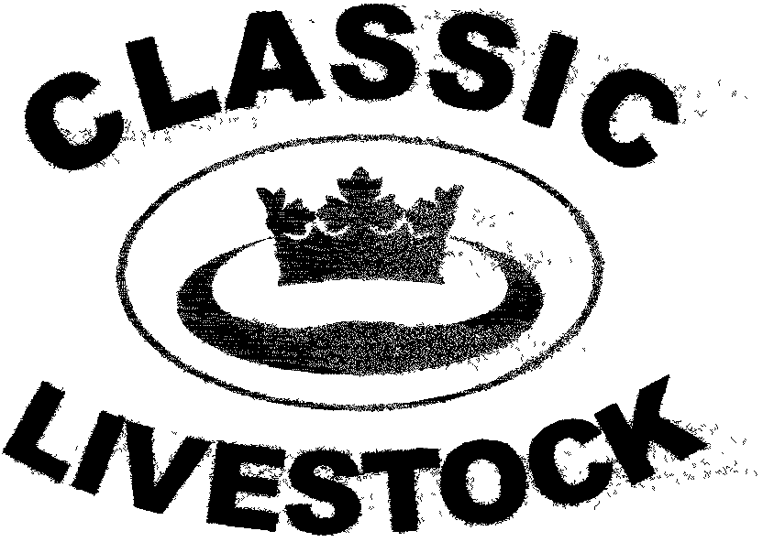

ACN 092435571

P.O. BOX 1181, PHONE: 0741297029.
MARYBOROUGH, 0411201879.
QLD. 4650. FAX. :0741297029.
Email:classic@classiclivestock.com
Website:www.classiclivestock.com
EDITORIAL.
Welcome to our latest newsletter. I hope that at least some of the information in previous newsletters has been interesting for you. I would welcome any feedback about the content as it is always helpful to know if what we are discussing is relevant.
As with our evaluating system itself, I am trying to add related topics to the newsletter to assist with balance, not only with our livestock enterprises, but with our whole lives. I know that some of the things that I discuss may raise issues some of us are not necessarily all that comfortable with, but as I have indicated in earlier editions, if one part of the management system is not healthy then it will impact on all the other parts, whether we like it or not.
From a personal perspective, I guess I am in a somewhat unusual, or unique position of having been a livestock producer for much of my life and now in later years have followed interests in other areas including personal development and how our mental health is just as important as our physical health regardless of what we do. Sure, the balance will vary a little depending on what our specific vocation is, but overall we cannot function at our best if that balance is missing.
I find it interesting to be able to discuss with producers those areas of their business that are not as effective as they would like and asking them what they would change that would lead to obtaining more balance in their enterprise. Quite often it is about our approach or attitudes and these can vary as much and as often as the weather. One of the great things that I have observed is that those producers who know themselves well also know the other parts of their business well and they have a stillness within that is very powerful to witness.
THE CHINE

This is a part of the animal that we use in our assessment of traits in cattle to assist with evaluating their overall confirmation. When we talk about the chine we are referring to the area of the spine from just in front of, to a few centimetres behind the shoulder blades.
When we first started putting together the most important traits to measure as part of our evaluation system, we had the chine as a separate trait. However, after a lot of discussion and observation, a couple of factors influenced us to leave it out of the primary traits.
The two main factors were:-
- That the chine influenced some of the other confirmation traits that we had included as primary traits such as body capacity, shoulders and angularity.
- That its position is different dependent on the breed of the animal and more specifically whether it is a dairy or beef breed.
What we now do is still use the chine as a factor in evaluating the confirmation of cattle, but it depends on the breed and use of the animal as to where we consider the position of the chine to be in each case as the most relevant factor.
In beef cattle, we usually like to see the chine slightly above the shoulders and no more than about 2 -3 cms. higher than the point of the shoulders. This will usually mean that the animal will be less angular, but still have a good rib spring and be able to take in an ample amount of food and oxygen to be highly productive.
In dairy breeds, a higher chine will increase the angularity and whilst reducing the anatomy of the animal to carry larger muscling, especially in the front half of the body, it will not have a significant impact on their capacity to take in food to produce more milk.
Again, as with all the traits that we consider when evaluating animals, balance is the key. By that, I am referring to the balance between the traits and how each of them influences, to some degree, the other traits and ultimately the overall confirmation of the animal. Certainly, the prominence or other wise of each trait will vary from animal to animal, but the closer to perfect each trait is it cannot help but improve the overall confirmation of the animal. It is also important to remember that just because the parts of the animal that we look at may be at opposite ends of the body, it doesn’t mean that they don’t influence each other and the animal’s overall performance. The relationship between the muzzle width and the distance between the pins is a good example where we believe these need to be equal in a well balanced animal.
Therefore, we cannot emphasise the importance of seeing the whole body when evaluating and not just the one or two traits that might be dominant in either a good or bad way. The chine is one of the areas, as stated previously, that influences several of the key traits that we consider when evaluating and so whilst it is important, its importance is more with how it influences several parts and what affect this has on the animals overall balance, rather than what it is as a single feature on its own.

***************************************************

ANNUAL MEETING.
The company has just concluded its annual meeting so I thought I would just share one or two points that we discussed that might be of interest. This last year has been our best year to date from a business perspective with a modest financial result given where we are at now and still very much in the embryonic stage of the business. Interest is steadily increasing and our book sales have been encouraging. Some of our shareholders are involved in overseas businesses at present which, if they continue to progress in their current direction will have some spin off benefits for CLMS in coming years. This was one of the topics we discussed.
Whilst we are encouraged by the growing interest and the enquiries we are getting at present, most of them are coming from overseas or from smaller breeders/producers in Australia. There is also a growing interest in our system from organic producers locally.
Unfortunately, local larger breeders are still blindly following the direction of industry politicians and power brokers including scientists and stud breeders mainly interested in feathering their own nests and expanding their egos. Having said that, though, there are a lot of larger producers who would like to change their direction if they had a choice. This became quite evident during Beef Week this year when I had an opportunity to meet some of these people. Quite a few are disillusioned with what is happening in the industry, especially from a breeding perspective, but are unsure of how to change course. For example, when they talk about breeding composite breeds, they often comment about how that went against everything they had been taught by their forefathers about breeding. This has caused them to be caught between two “cultures” and they are often ending up too confused to make a decision to suit their own enterprise because of all the smoke and mirrors they are being faced with when making decisions about breeding.
Our members, too, are frustrated by the lack of understanding that old fashioned common sense tells them about such issues and even more frustrated by the lack of interest, even apathy, by producers and breeders to have the courage to make decisions that suit their particular enterprise rather than conform to the “sheep” mentality that is dominating the industry at present in this country.
Our members came to a unanimous consensus that our efforts are best focused on overseas opportunities where producers are more open to producing quality products and have been subjected to less brain washing by industry heavy weights. This is especially so in some of the developing countries where, although they have may have more social and political issues to resolve, they do value the need to produce high quality off a small area and focus on returns per hectare as the base measurement of success. A number of such opportunities were discussed at the meeting and will be acted on.
We also hope to have our updated website available early in the New Year. That will be somewhat dependent on how quickly I can master the intricacies of web site building, but I hope it will happen soon. Whilst we would like to share our knowledge etc. with you all at no cost, I am sure that you can appreciate that we need to make some return to keep our business viable. With this in mind we are looking at offering parts of our system and other information in a more segmented format that will be able to be purchased online at an amount quite a lot cheaper than our current book. This will mean that rather than having to buy the whole book, if your only interest is in breeding traits, then you will be able to buy that section at a much reduced rate.
We also discussed some value added options for meat products. We are still hoping to someday be able to market our meat on a stick concept. Currently, our partners in Canada are doing most of the development with this product and although it is proving very popular with the general public during trade and food fairs, it is proving nearly impossible to find a distributing and/or retailing network willing to take on that role. This is very frustrating for all concerned because we know how good the product is, but we don’t have the expertise or resources to do the distribution in a way that is needed. We are also hoping to rekindle interest in Australia and plan to talk to possible manufacturers and distributors over the next few months to get it established here as well.
Overall, there was a lot of optimism shown at the meeting for the direction we are taking and our main aim now is to continue to be patient with our development and be available to take the opportunities as and when they present themselves. We also want to strongly urge anyone interested in the system to contact us. Our absolute focus is on developing meat and milk products that are consumer friendly, balanced in all ways and repeatable from breeding perspective.
***************************************************
For the world to change, first I must change.
The meaning of our communication with others
is the response we get.
Always provide choice – never take it away.
**************************************************
WHAT ABOUT CONTROL?
In this newsletter, I just wanted to share some of the signs to look for from a psychological perspective and how to work with them positively so that they don’t take control of us. We are all very familiar with control and what it can do to our lives.
Take a few seconds, now, to recall a time or times when you felt totally out of control or were totally at the mercy of some one or thing. Not all that pleasant is it and not a place we want to go again if we can help it.
Now become aware of a time when you felt totally in control. Whenever you said jump or whatever, you got an immediate response. How good was it to feel that power?
I would venture to say that in both cases, what you remembered, the picture you saw was mainly physical and external. As you think about those times, ask how you could have changed those situations into something somewhat different and how that would be. I am quite sure that you would all like to change the times when you felt controlled, at least. How difficult is it for you to change those experiences into something different? There are a number of processes that can assist in doing that but I don’t intend to go into those now. Maybe in another newsletter. Suffice to say that I believe some of you would have already changed those experiences just by changing the shapes or colours in the visual images you just had. When you do that, you can’t help but feel differently about your changed perspective of the experience. Some of you would have been immediately aware of feeling something different while others became aware of a difference when I just mentioned it.
Quite often with external experiences it is more difficult to change the experience because there are a lot of other external factors influencing the change that we perceive as being “out of our control”.
What is much more within our scope to change on personal level, but often not any easier, are the parts or part of us that is controlling us internally.
What I mean by that is how our internal parts such as fear, anger, guilt, jealousy, creativity, happiness, peace, satisfaction and so on can control us. Now, there are times when that control is very useful. In the case of fear, it needs to have a fair amount of control at certain times, such as when we are working in a yard of scrub bulls. If we have no fear, we are likely to just walk amongst them without watching fully and not focusing fully on the danger and where our closest escape route is.
That’s fine, but when fear gets the idea that it feels good to control in those necessary situations and starts to take over full time, then we can be in a spot of bother as far as getting on with a balanced life. The same applies to all our internal parts regardless of whether they are good or bad.
The more aware that we become of which part we need to control us in each situation, the more balanced our lives will be. In a sense, we need to talk to ourselves, or at least our internal parts so they know we appreciate what they do for us, provided it is at the right time.
On the other hand, when we see one or two of our parts taking control of our lives, our other parts tend to get lazy and just sit back and not contribute to any facet of our lives. If fear or anger or confusion, for example, get control, then it will impede our decision making processes and all our decisions will be made from the perspective of that part of us that sees itself as being in control. There are few times that we make good, balanced plans and decisions when we are controlled by things such as fear and anger. On the positive side, these parts are useful in most of what we do if they are there making a moderate contribution. Anger, for example is a great motivator, so it can get moving towards a decision that we need to make, but we then need input from other parts such as our creative part and our rational part. Fear is a great protector and so it will help us to be doubly sure that what we have planned is safe, both physically and from a business decision making sense. When you stop and think about it, you will see that we really have all the parts necessary to make decisions and plan that we need. It is a case of entering into a (usually) silent dialogue with each part and asking it what its contribution can be towards ensuring the success of the decisions and plans you are making.
I know that there is an old saying that says talking to yourself is the first sign of madness. I tend to think that the opposite is truer.
The positive thing is that most of you will do what I have explained at an unconscious level anyway without really being aware of it. What awareness does is open the doors of possibility even wider for you to be more balanced and positive in your decision making and planning etc.
***************************************************
Life is a journey – not a destination.

The map is not the territory – The picture is not the person

***************************************************
GROWING OUTWARDS
Because of the increase in interest in our system over recent months, we are now looking much more seriously at expanding our development and conducting more field days and demonstrations of the system as well as doing more on farm cattle evaluations. Despite the fact that, as stated earlier, there is not a lot of direct interest from grass roots cattle producers in Australia at present, we believe that if we can gradually expand what we are doing and others see the benefits of becoming involved then more producers and breeders will take the system as seriously as it deserves to be taken. We also know that for the system to be more accepted, we need to get enough producers using it so that a market chain can be established that will reward those who use it.
The response that we have received from the field days that we have attended and been part of over the last few months has reinforced to us that there are people out there who are looking for other ways tp breed and manage their livestock.
We believe that our system is not that “far out” that if it is given an even chance that it will prove itself to be a valuable contributor to the industry. Whilst we realise the importance of science in taking the industry forward, we have also stated that there are some things that have stood the test of time from a very practical base that are being ignored today.
We are asking for the opportunity to prove what we are saying has a lot of merit and we believe that the time is right for us to push forward now and share our ideas on a much broader stage.
We are hoping that there are producers out there who will work with us in these early days because they will reap the benefits.
*************************************************************
HIDING THE TRUTH
A 54 year old woman had a heart attack and was taken to the hospital. While on the operating table she had a near death experience. Seeing God she asked "Is my time up?"
God said, "No, you have another 43 years, 2 months and 8 days to live." Upon recovery, the woman decided to stay in the hospital and have a face-lift, liposuction, breast implants and a tummy tuck. She even had someone come in and change her hair colour and brighten her teeth! Since she had so much more time to live, she figured she might as well make the most of it.
After her last operation, she was released from the hospital. While crossing the street on her way home, she was killed by an ambulance. Arriving in front of God, she demanded, "I thought you said I had another 43 years? Why didn't you pull me from out of the path of the ambulance?"
(You'll love this)
God replied: "I didn't recognize you."
***************************************************
Thank you for your continued interest in our newsletters, our website and our book. Please feel free to order one of our books and become familiar with the CLMS system. and the directions we are taking in the overall scheme of animal and food production for human consumption
PLEASE FEEL FREE TO CONTACT US ABOUT ANY ITEMS IN THIS NEWSLETTER, ON OUR WEBSITE OR IN OUR NEW MANUAL. WE WELCOME PRODUCER INPUT AND INTEREST AND WANT TO INVOLVE YOU IN WHAT WE ARE DOING.
Disclaimer: - Information contained in this newsletter is believed to be true and accurate at the time of publication. Classic Livestock Management Services is not liable to any person or organisation, whether in negligence or other wise for anything published or omitted from this publication.

