THE
HORMONALMMAIL

THE OFFICIAL QUARTERLY NEWSLETTER FOR CLASSIC LIVESTOCK MANAGEMENT SERVICES

VOLUME 1. NO. 4.

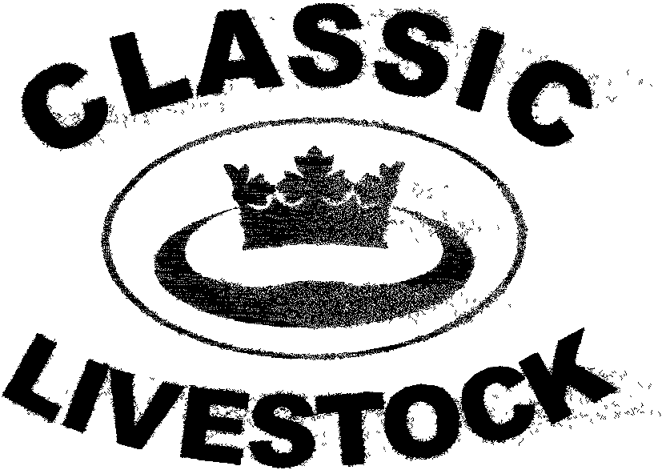

ACN 092435571

P.O. BOX 1181, PHONE: 0741297029.
MARYBOROUGH, 0411201879.
QLD. 4650. FAX. :0741297029.

Email:classic@classiclivestock.com

www.classiclivestock.com

EDITORIAL.
The last three months have been a time of little practical activity for the company in terms of field work. However, it has seen the completion of the new book that explains our system. We must apologise because it has taken a little longer to put together than originally anticipated. The result, though, will be well worth the wait. The outline of what was planned for this new book was covered in the last newsletter so I won’t expand more on it here. The main reason for the delay is that we want to ensure that this book is of the highest quality in terms of information availability and that it provides a very good financial reward for those who use one or more of the management strategies that form the system.
The book is the result of many years of learning and research and will be a valuable tool for all livestock producers. It outlines small (and large) changes in management strategies and in our understanding of animals that we know from our own experience will repay the cost involved many times over and produce a much more sustainable and quality orientated system.
The book will be available for purchase through our website as a hard copy and we are also considering a release as an E book. Price details will be available on our website at the time of release in early June.
The other item that I just wanted to touch on is covered more fully in one of the articles in this month’s newsletter. Again, it refers strongly to one of the basic fundamentals of our system and I refer to balance. This factor is something we have promoted as being critical to all aspects of livestock production and in this article it is again highlighted in the context of research that is carried out with only specific parts of a system being considered.

COMING EVENTS

JUNE 07 – “Touch The Vision Tender” – the CLMS system book launch.
Oct. 07 – Visit North America.

NORTH AMERICAN VISIT.
Again we seem to be having difficulty setting some firm dates to visit North America and share our thoughts with producers in that part of the world. We have had a couple of producers in Canada offer to assist with the logistics of an evaluator training program and some 1 and 2 day forums and for this we are very grateful. Our difficulty is in finding a time that is most acceptable to the greatest number of producers. The other factor that has made planning a little more complex is the ongoing drought here in Australia that means that some of our key personnel who would be involved in presenting parts of the program are currently committed to hand feeding their main breeding stock to get them through this very trying time. It is hoped that this situation changes through the winter and that we can visit in the North American Fall this year. We apologise to those of you who we know have been looking forward to meeting and sharing knowledge and learning with us.
************************************
PUT THESE IN YOUR POCKET.
As you go through life, take the following:
- A five cent piece so you can never be completely broke.
- A rubber band so you can stretch your savings to cover your debts.
- A paperclip to help keep your head together when the going gets rough.
- A bandaid to heal wounded pride.
- A napkin for when your mouth runs away with you.
- A marble for those days when you think you have lost yours.
INDUSTRYCONTROL - WHO HAS IT?

Whether we like it or not, the livestock industries today are controlled by forces outside its immediate control. Breeders and producers are at the bottom of the control hierarchy and yet there would not be an industry without them – as simple as that. Producers and breeders have allowed themselves to be strangled by outside interests and are gasping for every last breath, too weak now to defend themselves and their livelihood. Many of them are the perfect example of modern slavery in today’s highly technological and commercial culture.

The detractors who have dismissed the material we have put together and don’t believe the system has any significance for the industry are either not producers or have a vested interest in activities outside the breeding industry. Unfortunately, they also have a great deal of the power and control in the livestock industry and use the excuse for their rejection as a lack of scientific evidence. We are consistently being asked to accept scientific research as being the conclusive answer as to why we should just accept things as it says without question and often without having it fully explained or the methodology closely examined.

The instances that have been brought to light of very loose methodology used in trials to show that genetically modified plants have no effect on human health is just one area that every responsible citizen should be questioning much more rigorously.

We are not questioning the integrity of the many responsible and conscientious members of the scientific research community who are not swayed by public opinion or the lure of large cash rewards and huge ego boosts. What we are doing and what we are encouraging the general public to do is ask more questions about what the food industry is doing to our dietary choices.

Our company has put together a large amount of data now on the livestock industry which, admittedly, hasn’t been greatly publicized, but there has been enough contact with the research community to, at least, have encouraged it to have discussed our work with us. This hasn’t happened.

The option has been an investment of many millions of dollars of taxpayer’s money in many countries around the world into research and trials that we know full well that we have the answers for. Because it is not in a form that the few people in control and benefiting from this funding want to consider and understand, they are totally ignoring us and spending millions of dollars publicizing their own work that is really leading the industry in a very questionable direction and proving not to be in the best interests of human health. It may be making millions of dollars for a few very large organizations, but at what and who’s cost?

To us, these researchers are taking the easy way out because we challenge them to scientifically prove our work to be incorrect.

We stand by the system we have developed and know that it has a higher success rate than any so-called scientifically developed method of animal selection. It is also designed to retain nature’s control over the way stock grow and develop without scientific manipulation that in many cases, especially when trialled by multi-national drug companies, is based on very dubious true scientific methodology. As already mentioned, recent history, particularly in North America, highlights the methods that these companies will use to have their bio-technology and genetic manipulation methods approved for commercial use. (see Seeds of Deception, Jeffrey M. Smith, 2003).

There is a level of frustration within our company because of the way that the industry is brain washed to the highest level by politicians, bureaucrats and multi-nationals to play the game their way. Producers are being played a Pied Piper like tune by these manipulators to increase their wealth and power base. They are not interested in what they can put into the industry for grass roots producers, but what they can get out of it with as little input as possible. Unfortunately, some of the industry leaders in all the major livestock producing countries and particularly in the cattle industry, have been duped (or even possibly bribed) into supporting these players and have then exerted these influences down through their industry bodies, breed societies etc. in such a way that the grass roots producers really don’t have any choice but to follow along if they want to survive.

Grass roots producers have absolutely no control over their own industry regardless of what the spin doctors might expound. The people at the top of the chain, the politicians, bureaucrats and multi-nationals just feed enough crumbs of reward to the grass roots industry leaders so they can mount a convincing enough argument, usually given to them by the above, to rally the grass roots producers into doing it their way. These arguments are too often based on dubious scientific or other research and coated with attractions of higher yields, more profits etc.

It is time that producers started to make decisions about their own enterprise themselves, because most of them know what produces good quality or at least their forefathers did and that is a major part of what we are resurrecting to restore the industry back to some basic semblance of natural balance.

A BIGGER BALANCE
There is no doubt that the part that all the various disciplines of science have played in the understanding of the world around us has had a significant influence on the lives we live today. Science has provided explanations and understandings of the world at an increasingly escalating rate over the last few decades and most of us never cease to be amazed at what it will discover next. It has certainly had a major impact on the way we produce and manage our livestock.
It has offered explanations and reasons for many animal phenomena and provided answers to some of the biggest challenges in the industry. It has been able to produce tools that allow us to quantify many factors that are of great value in understanding how to produce animal products. It has identified diseases in animals and found cures for many of them and identified genetic indicators that explain how certain animals perform the way they do and how others don’t. It provides a whole range of tools which measure things like growth rates, fat thickness and type, blood quality, DNA, digestive capacity and so on.
Even with all the great contributions that science has made to our world, most scientists admit that there are some things that it will probably never be able to explain or understand. Some of these things may be some of the things we discuss in our system. To appreciate this, we need to look at the big picture and the universal balance between all things.
It would be nearly impossible, even in today’s world, to conduct research and take into account the affect of all the universal factors that influence each single part of the universe. To take into account how each object has external influences and the degree to which that influence affects that thing is, in most cases, impossible to measure because of the infinite degree of those external influences. Certainly, in many cases, a very good measure of what reaction or reason causes certain responses from objects can be made.
However, in most cases, there is a ripple affect across a range of other objects that are related to, or in the vicinity of, the object in question. This ripple affect can go on infinitely without us having an exact idea of the affect that it has on all the objects it comes in contact with. Each item in the ripples will respond differently.
The basis to a balance in anything is unity. Whether we look on that in a universal sense or at the level of a minute, atom sized object if there is not unity, there will be chaos and hence an imbalance. This applies to every natural thing, and in our case, to the livestock we breed and nurture.
One of the main keys to success in what we do as livestock producers is geared to our perception of the universal law of unity. One of the reasons we don’t see this unity is because we are reduced to seeing only what the realty of our senses presents for us. To truly see the unity of all things we need to see past our senses that separate things to the deeper connectedness and consciousness that links all things to the whole.
Another reason for the illusion of separateness that we are so often induced into following is the need to quantify every separate object or thing into a box of its own. In a sense, this is a product of the technological world of today. This need to put everything into a material or objective form and measure it, name it and understand it. It has led us to be forever thinking in a surface type structure of consciousness that cuts reality up into small fragments so that they can be studied in their isolation. This compulsive thinking is fine when we need to be totally focused on one really important goal that is happening in a moment in time and we are aware that that goal is not the only thing in our lives.

To be solely in that space all the time leads to this fragmentation of the bigger picture that isolates us from our universal connectedness. Some of the people that we have learnt the most from in our quest to put together this system have been producers who see not only the vision of a well balanced animal, but also the way they respond to their environment and the environment to them.

We have discussed how this applies in the cattle breeding industry when we focus on one part of a beast. This has been happening before our very eyes over the last 50 years and has resulted in an imbalance and the production of lower quality products. Certainly, we may be producing more of them but at what cost?

Single trait selection is an example of this focus on isolated parts of a beast, whether it is for meat or milk. There is a disunity of the key parts of the animal. What does selecting for a fast growth rate do to the confirmation of females and the positioning of the hips, pins and thurl that is critical to easy calving?

It is critical that whatever we do, whether it is in the bigger picture of the natural world or in our own individual breeding programs, we don’t take our off the ball in regard to unity between parts and therefore balance. If two parts side by side don’t fit in perfect until then the result will not be balance or natural perfection.

HOW FAT OR NOT.
In many of the grids used today by meat processors to measure the quality of a carcase, fat and fat depth or thickness plays a large part. We would question just how relevant fat is to the quality of meat and in particular, the depth. We feel there is certainly a correlation between fat and the palatability or taste of the meat and this can be influenced by the feed that the animal eats prior to processing as well as to its overall feeding and growth history.

However, we would strongly question its relationship with tenderness. At best, the interspersion of fat particles in the muscle of the meat, commonly known as marbling, will give a perception of that meat being tender. However, if that fat could be removed the remaining meat may well not be as tender. We feel that a more accurate measurement of the fat’s importance to the particular meat would be to test it for the level of unsaturated fats and then compare that to the tenderness of the meat it comes from.

Our thoughts are that there would be a stronger and much more valuable correlation between the level of unsaturated fats and tenderness than between fat thickness and tenderness. Certainly, beasts with a good, even fat cover look good and are attractive to the eye. This does not necessarily mean that its meat is going to be tender. A sleek, fat, heavily muscled Charolais or Angus certainly looks, on first impression, that it would have more tender meat than, say a Jersey, with an average body score. However, our experience is that this is not always the case and that you need to see what is under the skin, either literally or practically, before making a judgement. Quite often, the Jersey or dairy breed, despite only being accepted as a milk producer, will often produce a better quality meat than the beef breed.
Why is that?
The CLMS system outlines the reasons behind this and, in particular, the trend to breed only fast growing, fast weight gain animals without taking into account all the other traits that make the beef animal what it is supposed to be, that is, a producer of high quality meat. Again, the near fanatical desire to cross breed anything and everything in the beef industry bears witness to this trend.
Just compare the amount of cross breeding in the beef industry with that in the dairy industry and it indicates the mess that the beef industry is getting itself into. That is not to say that dairy industry is not guilty of single trait selection, e.g. breeding for quantity rather than quality in milk, but this has not been to anything like the way beef breeds have been crossed to try and get better results. For some reason, dairy producers have not been as tempted to contaminate their breeds as beef producers have. Another indicator is the number of beef breeds compared to dairy breeds and I use the term “breed” in a very loose sense here and how many “new” beef breeds that have emerged over the last fifty years. Is the industry any better for it and is the meat of a better quality?

Getting back to the point again after that small diversion, although relevant to the bigger picture, considering the relationship between unsaturated fat and tenderness would, therefore, provide a much more relevant indicator of meat quality, as well as being a useful marketing tool, given the emphasis today of avoiding saturated and trans fats. The tests to determine the fat type in meat unfortunately takes time and is relatively costly, so it is unlikely that processors are going to rush into using this as method of evaluating the quality of a carcase.

Scientists could well spend time developing a method of identifying fat quality on the kill floor or in the boning room so that meat can be graded even more accurately and quickly and with a measure that most consumers would recognise. This measurement would mean more to consumers in today’s world than fat depth. In fact, most consumers cut the majority of the fat off a meat cut before cooking it.

CLMS believe that to attain anything like the quality improvements that we need in the industry to improve the public acceptance of meat as a consistent, good quality product, then we, at least, need to identify the traits that we can select at the breeding stage that will give us a better chance of being successful in reaching this outcome. It would be even more valuable if scientists could develop a method of efficiently testing live animals for fat quality as part of a selection process for breeding. More research to prove or disprove a correlation between tenderness and poly unsaturated fats would provide a direction that could be followed confidently one way or the other.

Without having significant scientific data to support it, we do, however, feel that there is a correlation between the two. Why would tender, high quality meat be full of saturated fats and or trans fats? That is the question and gets back to the balance between parts in animals selected for breeding that score highly in all the traits we have identified in the CLMS system.

The way some people find fault, you would think that there was a reward for it.

PLEASE FEEL FREE TO CONTACT US ABOUT ANY ITEMS IN THIS NEWSLETTER, ON OUR WEBSITE OR IN OUR NEW MANUAL. WE WELCOME PRODUCER INPUT AND INTEREST AND WANT TO INVOLVE YOU IN WHAT WE ARE DOING.

Disclaimer: - Information contained in this newsletter is believed to be true and accurate at the time of publication. Classic Livestock Management Services is not liable to any person or organisation, whether in negligence or other wise for anything published or omitted from this publication.

