THE
HORMONALMMAIL

THE OFFICIAL QUARTERLY NEWSLETTER FOR CLASSIC LIVESTOCK MANAGEMENT SERVICES

VOLUME 1. NO. 6.

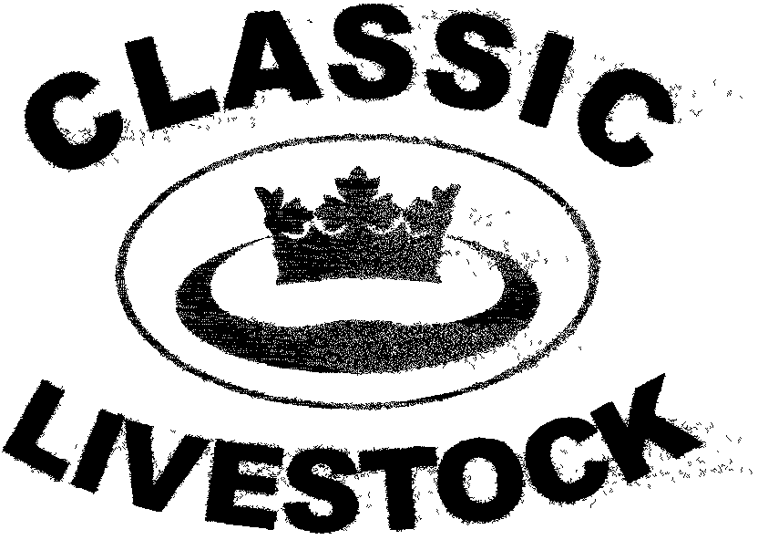

ACN 092435571

P.O. BOX 1181, PHONE: 0741297029.
MARYBOROUGH, 0411201879.
QLD. 4650. FAX. :0741297029.

Email:classic@classiclivestock.com

www.classiclivestock.com

EDITORIAL.
Welcome to another edition of the Hormonal Mail. I hope that all our mail list recipients receive their copy of this latest newsletter on time. There have been some difficulties in the past with getting emails through and we hope we have overcome these now. We have held this newsletter back a few days to allow for any relevant information that might come out of our annual meeting on October the 6th. to be added to the content.
In this edition we are going to discuss some more on the relationship between the food we eat and our health. This is a topic that we have introduced in previous newsletters as well as in our new book. One of our questions is about how changes made to the genetic structure of plants and animals that make up the human food chain to enhance certain characteristics will impact in the long term on human health.
Speaking of our new book, we have been a little disappointed with initial sales although our advertising has been very limited. It is hoped that as more people visit our website over the next few months they will take advantage of the opportunity to purchase the book. As we indicated in the last newsletter, it contains a wide range of relevant information and everyone will get something out of it that will more than justify the initial outlay.
To provide our readers with an idea of the content of the book, we have included one of the trait descriptions in this edition. Unfortunately, room won’t permit us to include the relevant diagrams, but we hope readers can get an idea of how we describe each trait. We have actually reduced the number of traits to 17 and this is to simplify the system still further although we have added more evaluation features to several traits to cover this overall reduction in traits. This, along with the addition of more information on hormonal activity and milk grading provides a very comprehensive evaluating system.
WHATS ON
Our company recently held its annual meeting and we felt the following points could be of interest to our readers.
- Lester Lodoen and his people in Canada are progressing slowly but surely with the development of the meat on a stick concept that we had researched as a value added option with potential. The possibility of this concept being accepted in Canada and North America appears to be much more likely than in Australia, at least in the short term. Lester has been very busy promoting the product at food trade shows and with distributors and retailers.
- Given the general lack of interest by the scientific and industry political communities in the work we been doing in affirming indicators of meat and milk quality that stockmen and women can observe practically on a daily basis as they work with their animals, it was resolved that the company would continue its research on an in house basis as resources and interest became available. It was also resolved to encourage producers and breeders to work with the company to affirm the system.
- Directors are satisfied with the interest in the company’s web site and have decided to continue to promote it both as a tool to promote the overall system and as a way of marketing the new book. The number of visitors to the site has nearly doubled over the last 3 months and this is encouraging.
- There has been some interest with some of our members to buy and agist cattle for overseas markets. The overseas investors in this business have expressed an interest in the system and as this market develops, have indicated that they will be looking at supplying the premium end of the market in their countries. They are aware of the CLMS system and when this happens, there will be an opportunity for the company to grade the animals to meet that quality end of the market. There will also be an opportunity for Australian breeders to have their cattle evaluated using the CLMS system so that they can take advantage of this premium end of the market.
- The company will also be inviting investors to join us in breeding herds based on meat and milk quality that can be used as future seed stock providers for a wider market as the demand for GUARANTEED premium quality stock increases.

The other topic I wanted to mention is not so much a coming event as a current happening event. I am referring of course, to the release of the latest update of our book. As mentioned, sales have been a little slower than we would have liked, but the important aspect from our perspective is that those who do purchase a copy are committed to their business and open minded about change. It is our wish that readers get information from the book that advances their business. As a company, we are very excited about being able to share our knowledge of the industry with breeders and producers alike.

*************************************
Driving down the highway was a large truck from a well known trucking company and on the back was the company’s slogan:
“We always go the extra mile”
Noticeable for all to see was another phrase scrawled in the dirt just below it:
“That’s because we missed the last Exit”
-----------------------------------------------------------------------------------
Q: Where do you find a crab with no legs?
A: Exactly where you left it.
BREEDING TRAITS
NO. 4 - FEMININITY.

This trait is included to highlight the importance of femininity in the selection of breeding animals and particularly with cows. It also includes a combination of the feminine features that are part of other traits as well as the importance of maternal characteristics in the animal. Look for animals with clean features and lines that highlight a balance between femininity and masculinity. Be wary of cows that have the features of steers.
We have left the figure descriptions in this summary, but space and page size does not allow us to do justice to the actual figures as they appear in the CLMS system book.

CHARACTERISTICS.

- The head, neck and shoulders, along with the rump and udder provide the main keys to this trait.
- A cow needs to have a wide and deep rump and a front that will support the rump area. The shoulder width and rump length should be the same. When this happens, it almost always means that the other main traits are in balance.
- The neck length of the cow should be one third of her total body length meaning that a well-balanced cow will be a third rump, a third back and a third neck.
- The flank is also a key indicator of femininity, fertility and maternalism. The rear flank should be at least 5 centimetres larger in circumference than the girth. A deep flank is a good indicator of milk production and cows with a deep flank will produce maternal daughters.
- It must also be considered that femininity is a trait that is important from the male perspective as well. If the trait for femininity is not strong on the male side then the result is cows that look like bulls, or at least, steers. Again, this is a situation where balance within traits is so important and highlights the need for a grading system like the CLMS system.

Figure 1 shows an animal with fine, sharp, clean features and a long angular neck that is neatly tucked into the shoulders. She will also have a long, angular, deep frame with a sloping rump and a neat, well-attached udder with evenly spaced and length teats. These are desirable characteristics of a beef cow.
Figure 2 highlights an animal that carries the main femininity traits to an extremity and are more characteristic of dairy breeds than beef breeds.
The third figure features an animal that is shorter and has far less stature elongation. The head is coarser and the ears rounder and hairier. The neck is short and thick. The rump will be squarer with no angularity. The udder has poor attachments, especially at the front and the teats are short and unevenly spaced. She is tucked up between the navel and udder and the brisket falls forward. Both these features indicate low hormonal activity.
*************************************
Talking about femininity, as we have been, here are:

SOME FOR THE LADIES

Men are like Laxatives ..... They irritate the crap out of you.
Men are like Weather. Nothing can be done to change them.
Men are like Commercials. You can't believe a word they say.
Men are like Mascara. They usually run at the first sign of emotion.
Men are like Parking Spots. All the good ones are taken, the rest are handicapped.
Men are like Department Stores. Their clothes are always 1/2 off!

GROWING
CONNECTIONS.
At our recent annual meeting, a lot of time was spent discussing the impact of breeding selection on the long term impact on human health.
This is a topic that we have raised previously, both in this newsletter and in our new book. The more we consider it and think about it, the more examples of a connection become apparent. In many cases there is no hard evidence to support our suspicions. This could be for several reasons, some of which could include:
Firstly, our suspicions are really just coincidences.
Secondly, these changes are just part of a naturally occurring cycle in humanity’s evolution.
Thirdly, those who do want to ask questions about what is happening in the world today just don’t have enough resources or loud enough voice to be heard.
Fourthly, the people controlling the direction of food production have too larger an investment to allow any questions to be asked.
Fifthly, the people with the research expertise to examine some of these trends that we have raised and many more that we haven’t, don’t have the resources or are controlled by politicians and companies who would not be well served by the possible outcomes of this type of research.
Sixthly, longitudinal studies of the type necessary to identify the long term impact of selective breeding are not popular with researchers.
One of the major medical challenges facing the general community today is the increasing number of people with asthma. Is this because young men with asthma were not enlisted for military service in either the first or second world wars? Are we now seeing the long term impact of this “selective” process on later generations because the percentage of young men left to produce offspring after these wars carried genes that allowed a greater possibility of their offspring developing asthmatic conditions? One of the down sides of war is that generally speaking, the people in the front line are the fittest and healthiest young men from their respective countries and, of course, are the most likely to be casualties. Therefore, the male genetic pool of those waring countries is weakened and whilst medical technology today may be finding cures for many past diseases and conditions that were life threatening, there are emerging new medical conditions that were not previously known to humanity. The increase in intellectual disabilities and conditions such as autism that we are seeing now are examples. The key question, of course, is where are they coming from?
Some of the reasons could well be linked with the loss of the fittest contributors to the human genetic pool being casualties of war. Another reason is that which we have been discussing in regard to the impact of genetic manipulation of plants and animals over the last few decades and the introduction of synthetic methods of agricultural production. It could also be a combination of both.
We have already discussed the impact of the trend to breed beef cattle for live weight gain and dairy cattle for production of milk quantity only and how these factors have been manipulated by food processors and distributors as well as marketing gurus in the guise of breeders.
I recently attended a conference about autism and aspergers syndrome conducted by our state’s main autism organisation. Two of the three key note speakers followed the medical model for treatment quite closely and encouraged the use of drugs as the primary method of control. One of these speakers was a dietician who lectures at one of the state’s universities and it was interesting to listen to him encourage people to use drugs prescribed by their children’s paediatricians as the primary method of controlling the condition. He did encourage people to eat a healthy diet of fresh fruit and vegetables as well.
However, to give him credit, he did invite comments from the audience of 200 plus parents and professionals in attendance about alternative dietary options that they had used that had been successful with their children or people they had worked with.
This was probably the most interactive part of the 2 day conference as many people offered alternative suggestions that they found worked with their children, in particular.
Successful dietary programs mentioned included an increase in a number of vitamins, use of fish oil, casein free food, gluten free food, fat free food, fresh fruit and vegetables only, non-processed foods and a2 milk to name just a few. Of course, the use of a2 milk certainly got my attention, given the work we have done to determine a correlation between tender meat and a2 milk. Unfortunately, few people had heard of it, including the guest speaker. It is also interesting to note that several people weren’t using any dairy products because of the casein content.
A2 milk contains beta casein protein. Does this mean the myriad of other milks that are generally available high in casein protein that is not beta casein and therefore more likely to cause health related side effects?
On the subject of all the different variations of milk that are available in stores today, we don’t know, generally speaking as customers, how the various processes that finally arrive at the packaged product actually affect the food value of the finished product. Certainly, the labelling will provide a guide to the main contents of the product from a nutritional and health perspective. What it doesn’t necessarily tell us is what type of product e.g. casein, is present when there are a number of different types of the same product that can make up the item for sale.
These can be biological products that can have a varying impact on things like the human digestive system and the body’s capacity to absorb or reject them.
Another prime example of this issue is in relation to fats, both in meat and milk. Certainly, the question of meat fats is one of the questions that our company would like to have a lot more research done on to clarify the situation. We have people in the health industry advising that people should not eat fat, full stop. Now, we don’t have enough evidence to say that such an action is not like throwing the baby out with the bath water. There is enough evidence to suggest that trans fat and saturated fats cause health risks in humans. However, what of poly unsaturated fats and fats high in 0mega 3? The least likely possibility is that these fats play a role in the human digestive process. Again, there is more information in our book on this subject. One of our future aims is to research the possibility of a link between poly unsaturated fats and tenderness in cattle.
This issue is not confined just to animal products. The fresh fruit and vegetable industry is in a similar predicament. The general consensus is that all fresh fruit and vegetables are good for us. What we would question is how these products have changed over the years and to whose benefit. Who of you who can remember can say that products like tomatoes and strawberries, just to name a couple of most obvious examples, have not changed in their taste and texture over the last 3 – 4 decades.
In both these cases, these products have undergone a breeding program that has resulted in them becoming coarser in eating texture and having a lower water content. These programs have been driven mainly by distributors and retailers to ensure a longer shelf life, which is justifiable from their perspective. What we don’t know is what has changed genetically in these products when the genes that ensure a longer shelf life become more dominant. How does this affect other genes that may control certain vitamins or minerals in the product that are really beneficial for our health. Instead of needing 1 kg. of the old version of a product to get the necessary benefits, we may need to eat 5 kg. of the changed product. The other factor to bear in mend is that if we don’t receive a minimum amount of that certain vitamin or whatever, it may not affect our health, but who knows how it may affect our offspring or their offspring.
These are just a few of many questions that we need to take responsibility for facing and examining in the future.
*************************************
MIND WORDS
We hope you enjoyed the mind words we put in the last edition and, of course, had no trouble working them out and so here are a few more this edition.
There will be a number of letters, numbers or even drawings illustrated from which a phrase or well known comment can be derived. The answers will be at the bottom of the last page.
- i.e .

- Hands
Hands
Hands
Deck.

3. T
T
T
3T

4. GAG
U

5. NO WAYS
IT WAYS

6. COLLAR
40 degrees C

- PRO/MISE

- KNEE
LIGHTS

****************************
What is the definition of the bravest man in the world?????/
The man who comes home drunk, covered in lipstick and smelling of perfume, then slaps his wife on the backside and says: “Your next fatty!!!”
A man walks into the bedroom with a sheep under his arm while his wife is lying in bed reading. The man says: “This is the pig I have sex with when you’ve got a headache.”
His wife replies, “I think you’ll find that is a sheep.”
The man replies, “I think you’ll find I was talking to the sheep.”
*************************************
ANSWERS TO “MIND WORDS”
- That is beside the point.
- All hands on deck.
- Teetotaller.
- The gags on you.
- No two ways about it.
- Hot under the collar
- Broken Promise.
- Neon lights.

Unfortunately, there will be more next time.

PLEASE FEEL FREE TO CONTACT US ABOUT ANY ITEMS IN THIS NEWSLETTER, ON OUR WEBSITE OR IN OUR NEW MANUAL. WE WELCOME PRODUCER INPUT AND INTEREST AND WANT TO INVOLVE YOU IN WHAT WE ARE DOING.

Disclaimer: - Information contained in this newsletter is believed to be true and accurate at the time of publication. Classic Livestock Management Services is not liable to any person or organisation, whether in negligence or other wise for anything published or omitted from this publication.

